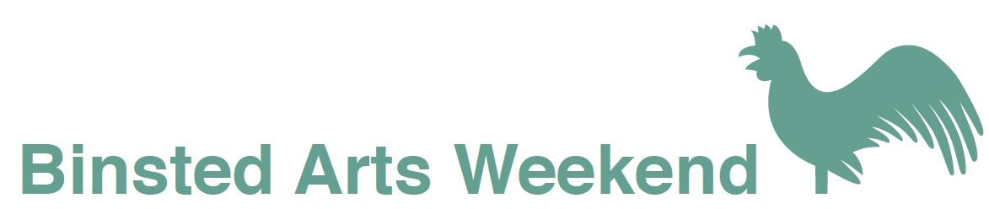

Poetry Competition

Judge: Maggie Sawkins

winner of the Ted Hughes Award for New Work in Poetry 2013 for her Live Literature production ‘Zones of Avoidance’.

Original unpublished poems are invited on the theme:

A way through the woods

Prizes: £100, £50, £25

Entry fee £5 for first poem, £3.00 for subsequent poems.

There will be a reading in Binsted Church (BN18 0LL)
of prizewinning and commended poems
with a commentary by Maggie Sawkins
on Saturday 11 June at 7.30

Poems, entry fees and forms should be posted to:
Competition Secretary
Shirley Park, Yapton Lane,
Walberton, Arundel, BN18 0AN

by
Sunday 17 April 2016

For full details of the Binsted Arts Weekend visit
www.binsted.org/arts-weekend

Poetry Competition Entry Form

Name...................................................................................

Address...............................................................................

……………………………………………………………………………

Postcode………………………………………………

Email...............................................................

Phone number.................................................

Title(s) of poems submitted

I enclose a cheque payable to Binsted Arts for £.........

Terms and conditions:

Send 2 copies of poems, each on a separate sheet, with entry form, to address overleaf.

Poems must be the original work of the named author and must not have been previously published or won a prize in any competition. No author names on poems - personal details to go on entry form.

Simultaneous submissions can be accepted subject to withdrawal if another prize is awarded.

Poems must not exceed 40 lines, must be typed, single spaced, in Times New Roman and 12 point.

The judge will read all entries and her decision is final. Copyright remains with the author. Winners and commended authors may be asked if their poems can be included on the Binsted Arts website and in a small anthology.

Further copies of this form can be downloaded from www.binsted.org/arts-weekend

